

CSA0501-DATABASE MANAGEMENT SYSTEMS

LAB EXPERIMENTS DATE: 29/07/2026

EXPERIMENT 21–MYSQL STRING FUNCTIONS- REPLACE, REPEAT,REVERSE, RIGHT, LEFT, RPAD,LPAD
AIM:
To implement SPACE(), SUBSTR(), UPPER(), LOWER(), TRIM(), and LENGTH() string functions using MySQL with the milka_dairy table.

Procedure
- Select the required columns from the milka_dairy table.
- Use the SPACE() function to generate spaces.
- Use the SUBSTR() function to extract a part of the customer name.
- Use the UPPER() function to convert the customer name into uppercase.
- Use the LOWER() function to convert the customer name into lowercase.
- Use the TRIM() function to remove unwanted spaces from a string.
- Use the LENGTH() function to find the length of the customer name.
- Execute each query and observe the result.

1. SPACE()

SELECT name, CONCAT(name, SPACE(5), bank_name) AS customer_bank

FROM milka_dairy;

Output:
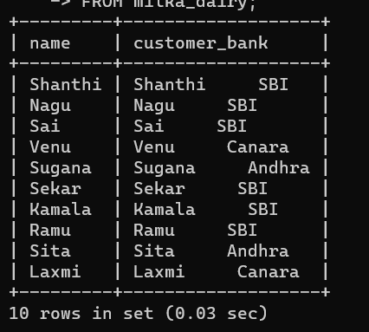

2. SUBSTR()
SELECT name, SUBSTR(name, 1, 3) AS short_name
FROM milka_dairy;

Output
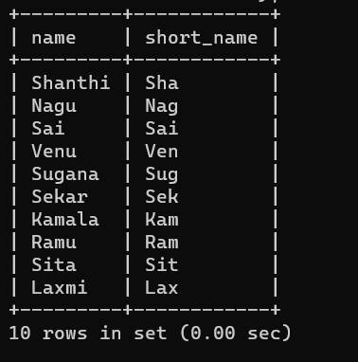

3. UPPER()
SELECT name, UPPER(name) AS upper_name
FROM milka_dairy;

Output

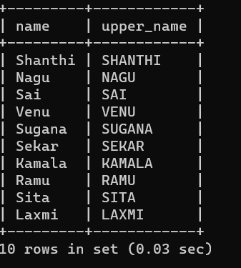

4. LOWER()
SELECT name, LOWER(name) AS lower_name
FROM milka_dairy;

Output
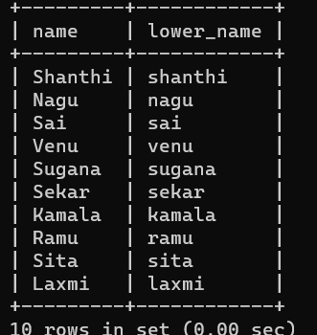

5)LEFT()
SELECT name, LEFT(name, 3) AS left_characters
FROM milka_dairy;

Output
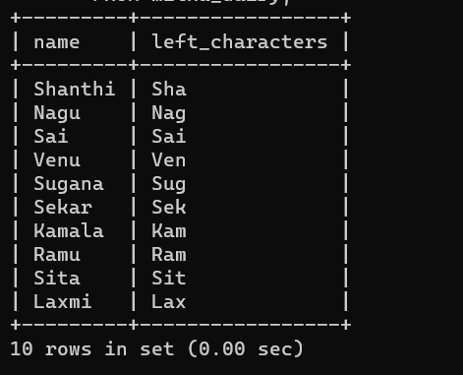

6. TRIM()
SELECT name, TRIM(name) AS trimmed_name
FROM milka_dairy;

Output
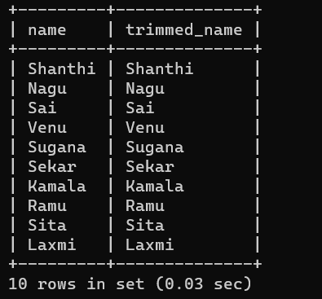

7. LENGTH()
SELECT name, LENGTH(name) AS name_length
FROM milka_dairy;

Output
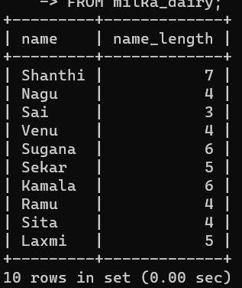

RESULT:
Thus, the MySQL string functions SPACE(), SUBSTR(), UPPER(), LOWER(), TRIM(), and LENGTH() were implemented successfully using the milka_dairy table.

